27.17: 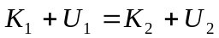
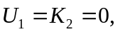so 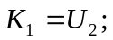 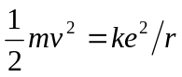
b) 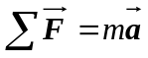gives 